M5Stack ESP32-Cam

Nov 16, 2018

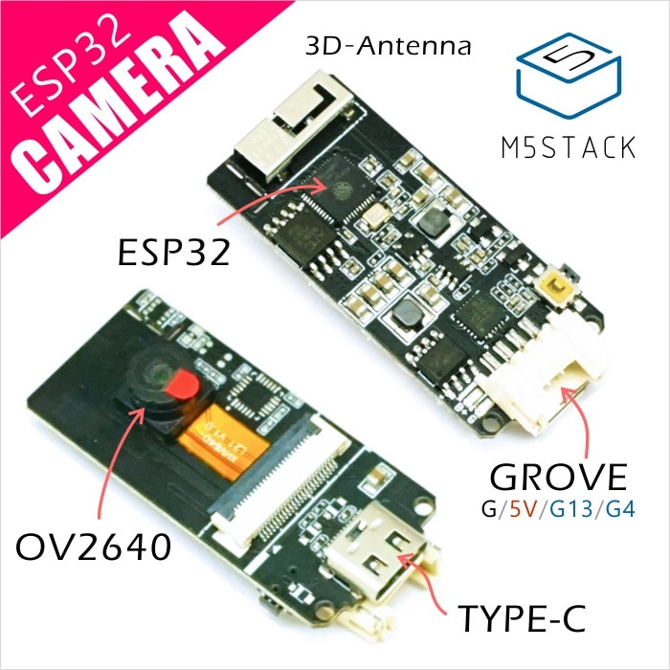

Aliexpress Store Listing (pricing is a bit flexible normally around $12.00 to $14.00)

<https://www.aliexpress.com/store/product/M5Stack-Official-ESP32-Camera-Module-Development-Board-OV2640-Camera-Type-C-Grove-Port-3D-Wifi-Antenna/3226069_32881414545.html?spm=2114.12010615.8148356.4.11c14ea1CPifCk>

The ESP32Cam is a tiny module based on ESP32 chip and OV2640. YOu can even program the ESP32Cam through the ESP-IDF by installing the ESP32 Core.

The ESP32Cam equips the ESP32 with everthing necessary to program, run and develop on the wonder chip. It also features a LiPo charger (IP5306), so your ESP32CAM project can be battery-powered and truly wireless. Additionally, the board reserved the MPU6050, BME280 and an analog MIC.

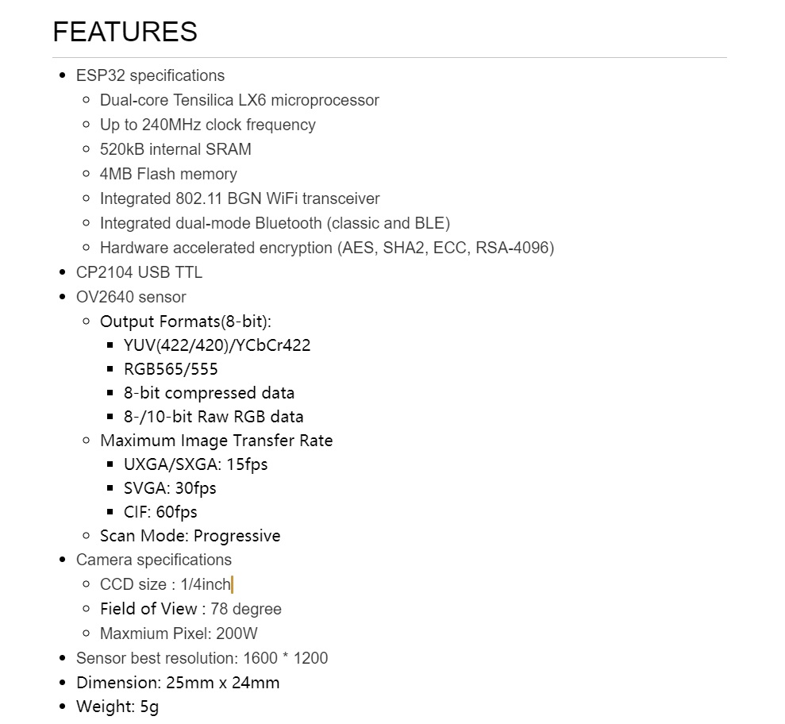

## Have The Camera Now What?

<http://forum.m5stack.com/topic/295/have-the-camera-what-now/7>

Stock Firmware:

Power it up. Look on your Wifi for an SSID like M5Cam. Connect your WiFI to it.

FInd the IP Address, mine was 192.168.4.1

Run a browser, I used Chrome, and type 192.168.4.1

Away you go.

the schematic can be found on this page <https://github.com/m5stack/M5Stack-UserGuide/blob/master/ESP32CAM.md>

the "demo" software as mentioned by jeff above sets it up in access point mode and then you can open either 192.168.4.1/jpg for a single image grab or 192.168.4.1/jpg_stream for a live feed

Or maybe:

[http://192.168.4.1](http://192.168.4.1/) is the address.

[http://192.168.4.1:80](http://192.168.4.1/) is the only open port.

<http://192.168.4.1/pgm> grayscale image.

<http://192.168.4.1/bmp_stream> - BMP stream.

<http://192.168.4.1/jpg_stream> - jpg stream.

prebuilt firmware:

<https://github.com/m5stack/esp32-cam-demo/blob/m5cam/m5cam-firmware.zip>

## Pin Configuration

<https://github.com/m5stack/esp32-cam-demo/blob/m5cam/main/Kconfig.projbuild#L44>

config D0  
 int "D0"  
 default "17"  
 config D1  
 int "D1"  
 default "35"  
 config D2  
 int "D2"  
 default "34"  
 config D3  
 int "D3"  
 default "5"  
 config D4  
 int "D4"  
 default "39"  
 config D5  
 int "D5"  
 default "18"  
 config D6  
 int "D6"  
 default "36"  
 config D7  
 int "D7"  
 default "19"  
 config XCLK  
 int "XCLK"  
 default "27"  
 config PCLK  
 int "PCLK"  
 default "21"  
 config VSYNC  
 int "VSYNC"  
 default "22"  
 config HREF  
 int "HREF"  
 default "26"  
 config SDA  
 int "SDA"  
 default "25"  
 config SCL  
 int "SCL"  
 default "23"  
 config RESET  
 int "RESET"  
 default "15"

## User Guide

<https://github.com/watson8544/M5Stack-UserGuide/blob/master/ESP32CAM.md>

## M5Stack Cam Viewer Project

<https://www.instructables.com/id/M5Cam-X-M5Stack/>

<https://github.com/moononournation/M5Stack-Cam-Viewer>

## Reddit and Github links

<https://www.reddit.com/r/esp32/comments/92423z/m5stack_esp32_camera/>

<https://github.com/m5stack/esp32-cam-demo>

### Other Github repositories that may work with this camera module

<https://github.com/donny681/ESP32_CAMERA_QR>

<https://github.com/ArduCAM/ArduCAM_ESP32S_UNO>